|  |  |
| --- | --- |
| **Web Game Development** | **Career Center East** |
| **Timberman Game** | **70 to 100 Point** |
| **Assignment Purpose:**  This game is about a little character that tries to cut up pieces of an infinitely large tree to get the highest score within the time frame. It is a skill and endurance game. You will be using the Phaser Game Engine. NOTE: Use Firefox to display and test this game. | |

**Setup**

Copy folder **Timberman** to your h: drive under the folder your teacher has designated.

You are given the code to run a complete Timberman Game. The Web site with the tutorial is located at <http://www.soluka.fr/blog/jeux/phaser-2-creer-timberman-en-html5-canvas/> .

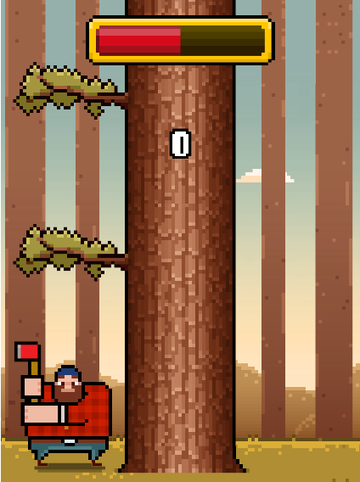

**70 to 100-Point Version**

Modify the template that was given to you to be unique. For example, change the forest scene to another scene like an ocean. Change the tree to maybe bubbles, change the limbs to starfish, and change the Timberman to maybe Spongebob. Use ***your*** imagination to create your own interesting Web game.